Azure CI /CD

<https://www.youtube.com/watch?v=xH5EY7FCFQw&t=2191s>

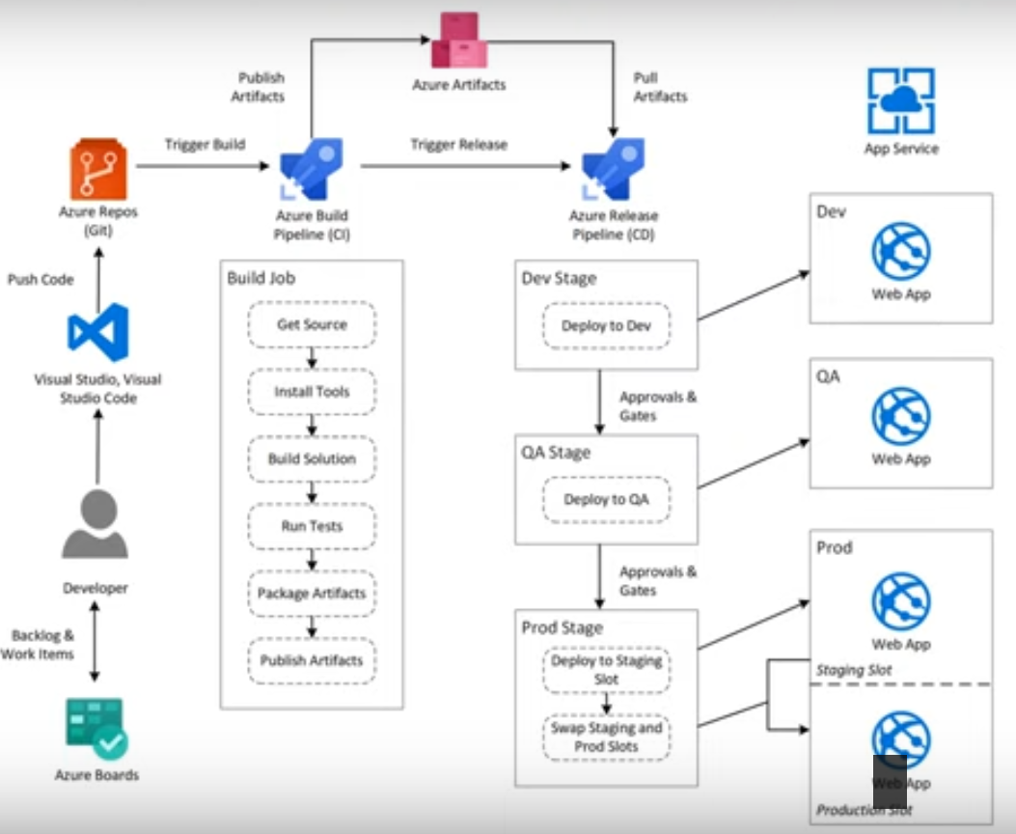

1. Developer create app and test at local machine
2. Multiple developer working on that , Azure Repos is Git represeantation
3. For that will create a pipleline (Build Pipeline /CI) which take source from Azure Repos
4. In Build job there are multiple tasks
5. Get repo from Azure Repos
6. Installed Required tools for source
7. Build solution
8. If we have any test project then will perform test
9. Then after build we package artifcats and publish Artifacts in Azure Artifcats
10. Azure Agent machine perform all Build Pipeline
11. Agent machine can be self /Azure hosted .
12. Then there will be Release pipeline (Dev/QA/PROD) , all these part of CD.
13. In Above pic , once Dev completed then it get into QA then further to Staging to Prod to minimize downtime.
14. Create project in dev.Azure.com
15. Bring project in Azure Repos

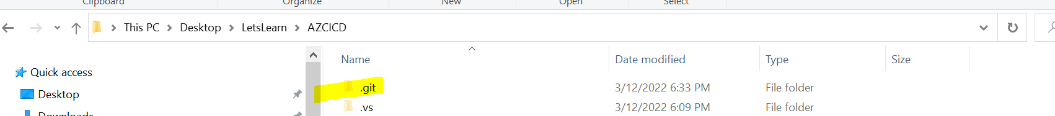

1. Add git ignore from VS
2. 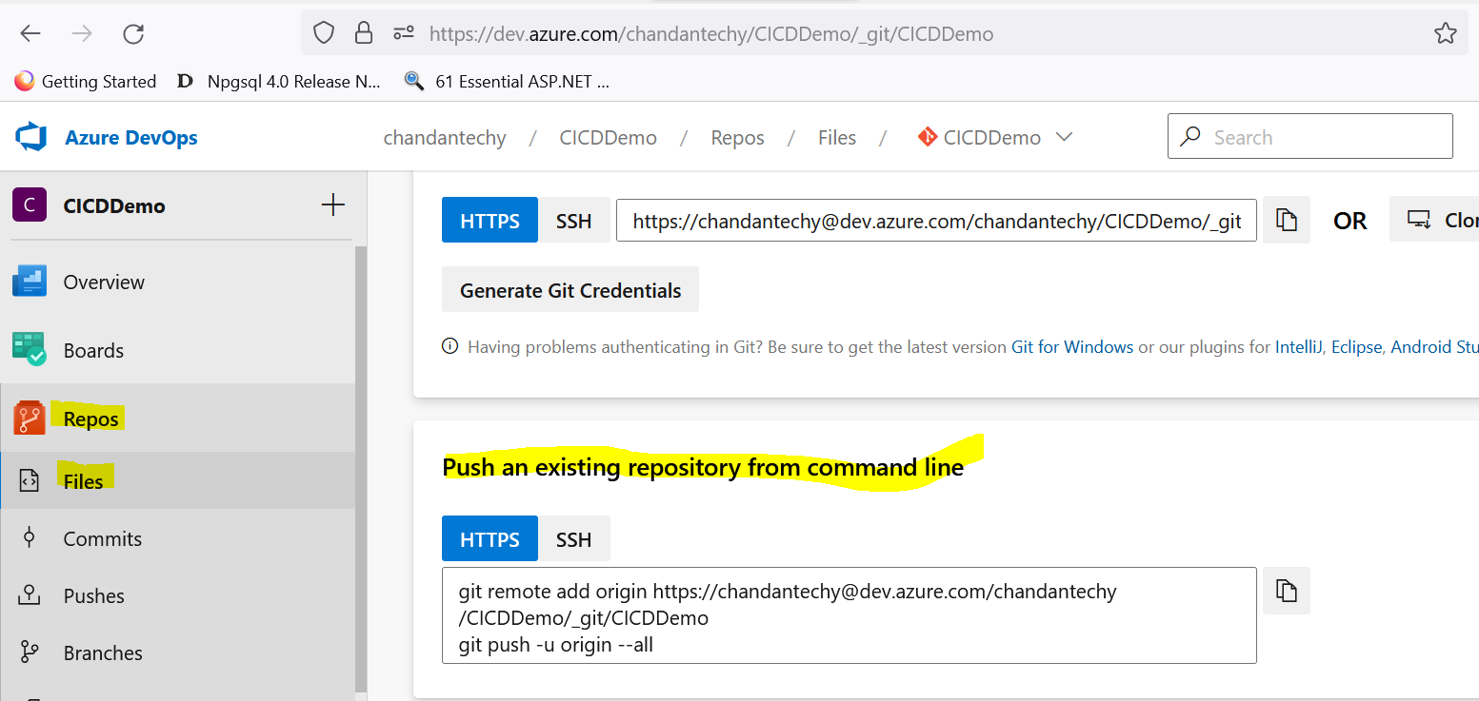
3. 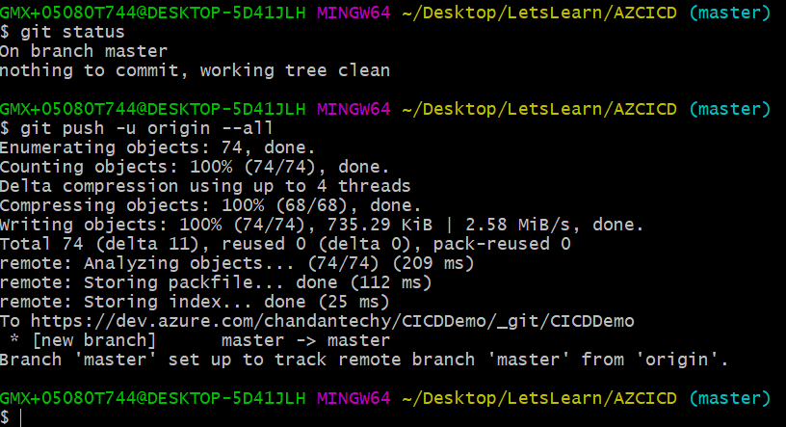
4. 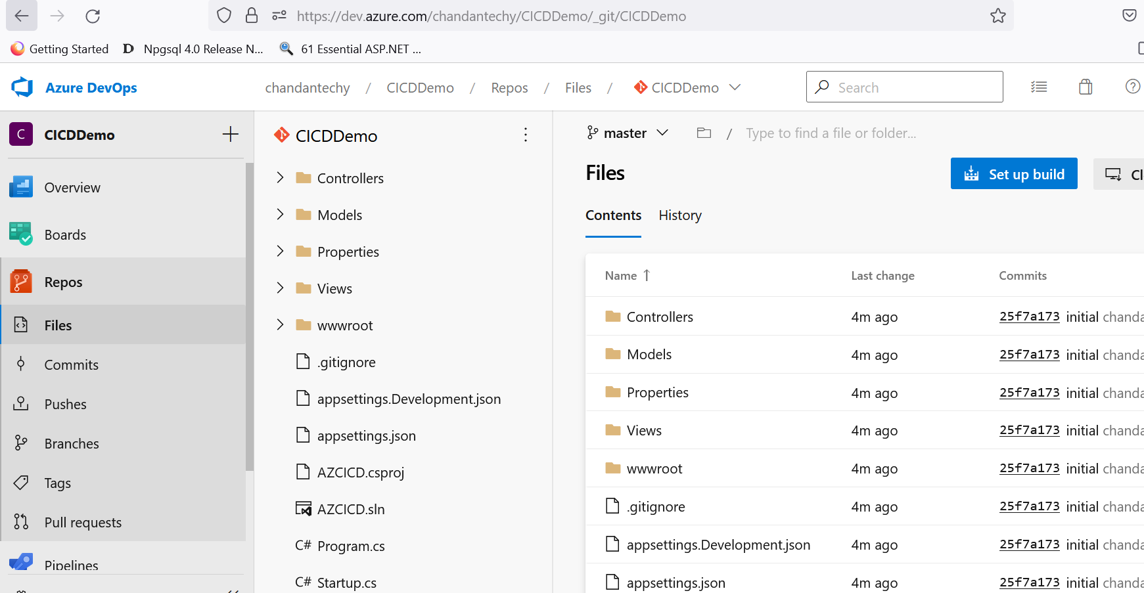
5. Now lets create Build Pipeline
6. Go to pipeline
7. Select Azure Repos Git
8. Select repository CICDDemo
9. Configure pipleline select .net core
10. 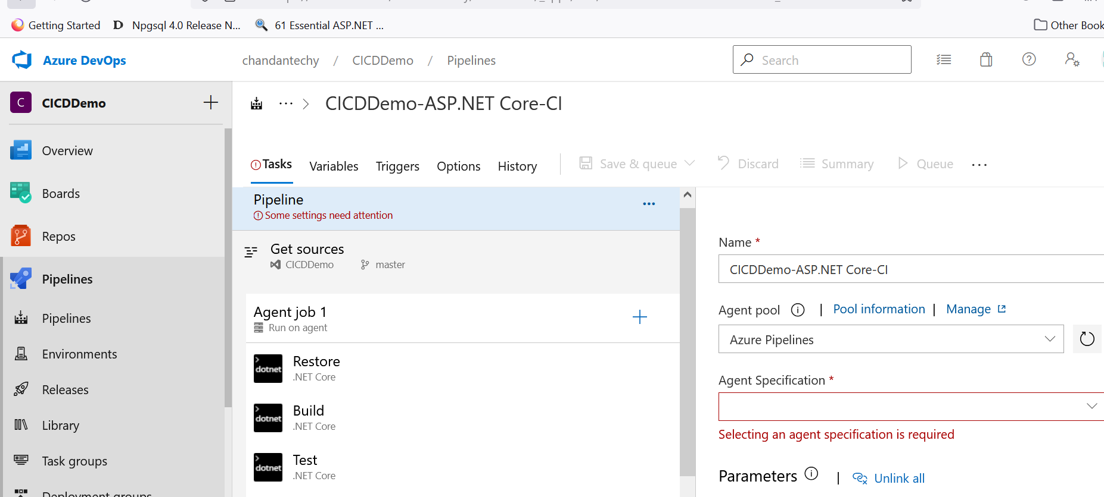
11. Azure Specification would be any OS
12. Azure pipeline if using Azure only , but if Agent is on some other place then we have to use default pipeline.
13. 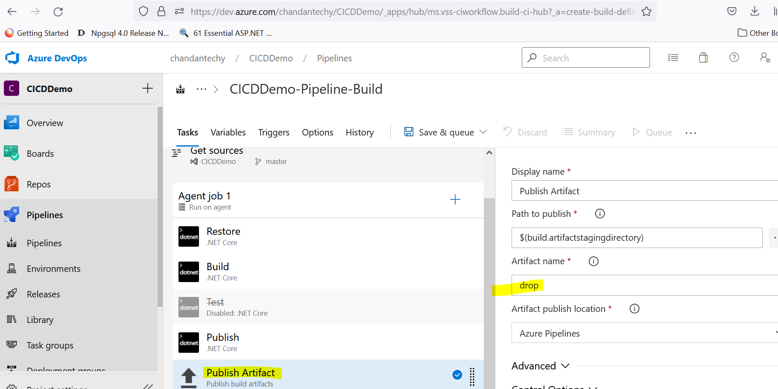
14. Save and Queue
15. Then we can set CI as true , so when we push code to Repos it will trigger and create Build , & we can schedule it as well.

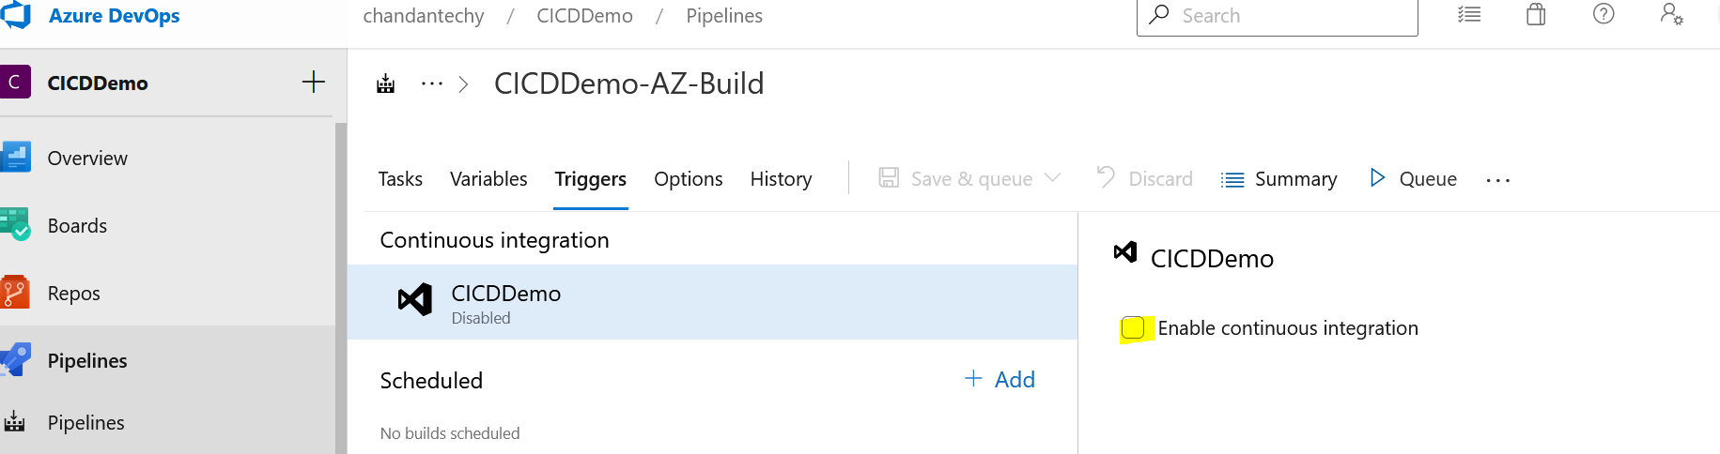

While running getting error : no hosted parallelism has been purchased or granted

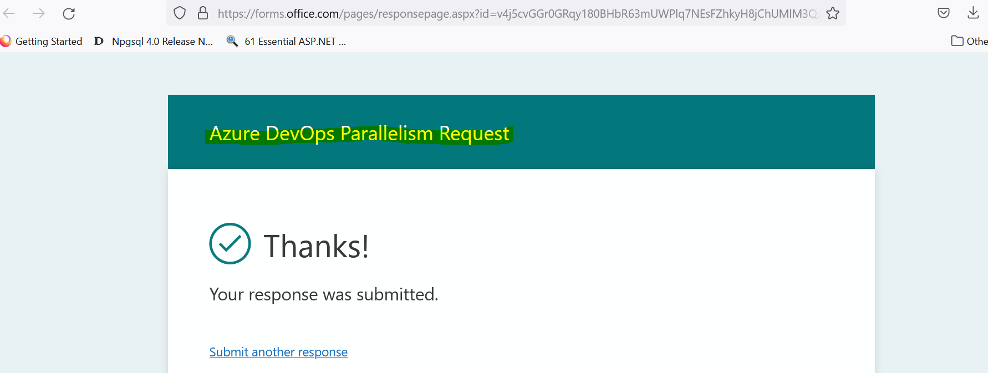

Then to Host Application , App services should be created

We will create 3 different App service (dev/QA/Prod)

1. On Azure Devops will create Release pipeline
2. In Artifacts section of Release pipeline , select Build Pipeline , select Latest version
3. In Project setting, Service connection , select Azure resource manager and select The subscription under which App services are created .
4. Then select Azure Subscription in Service connection and select App service name
5. Then Create Release after Pipeline created.